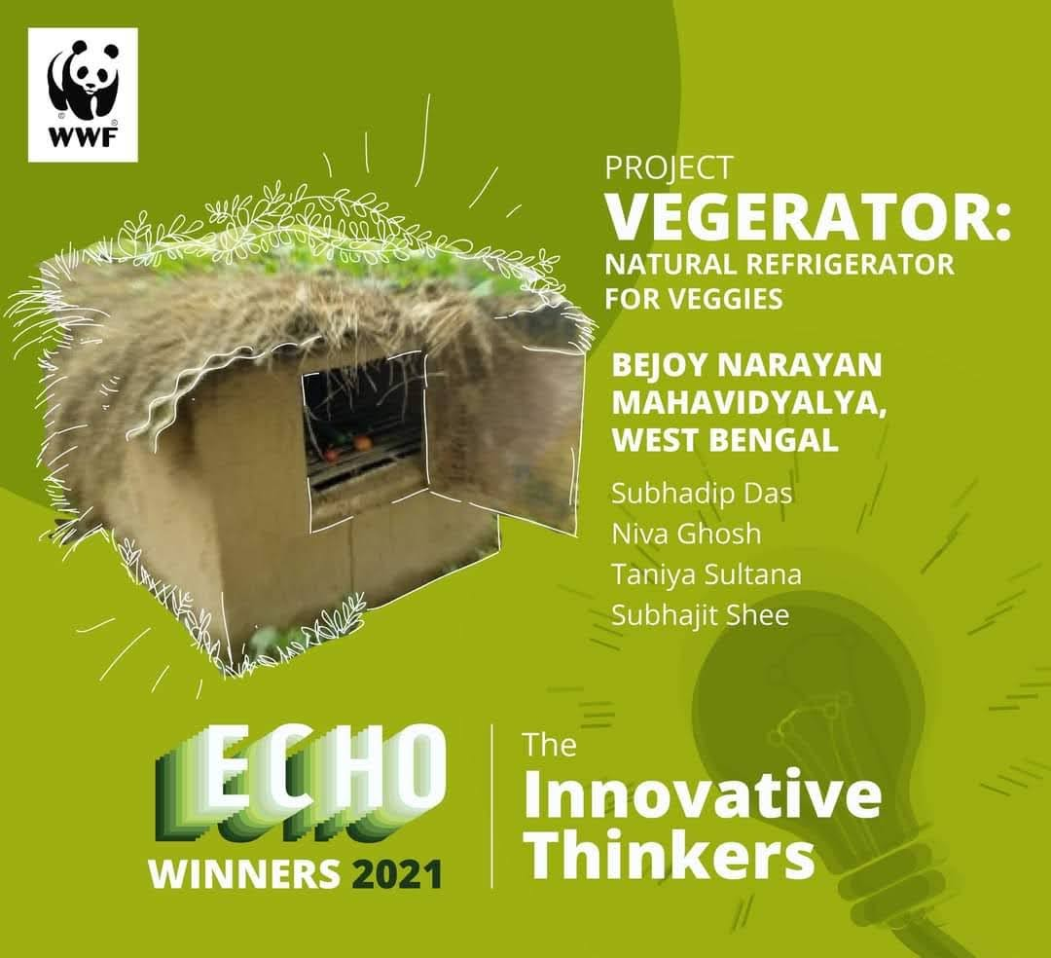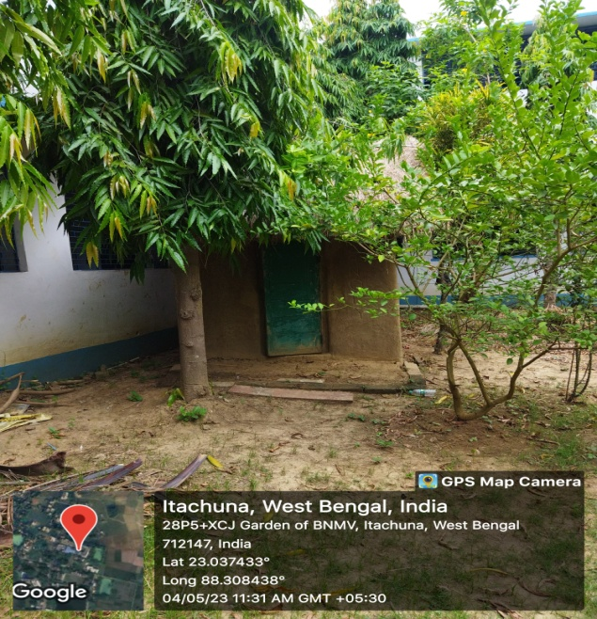

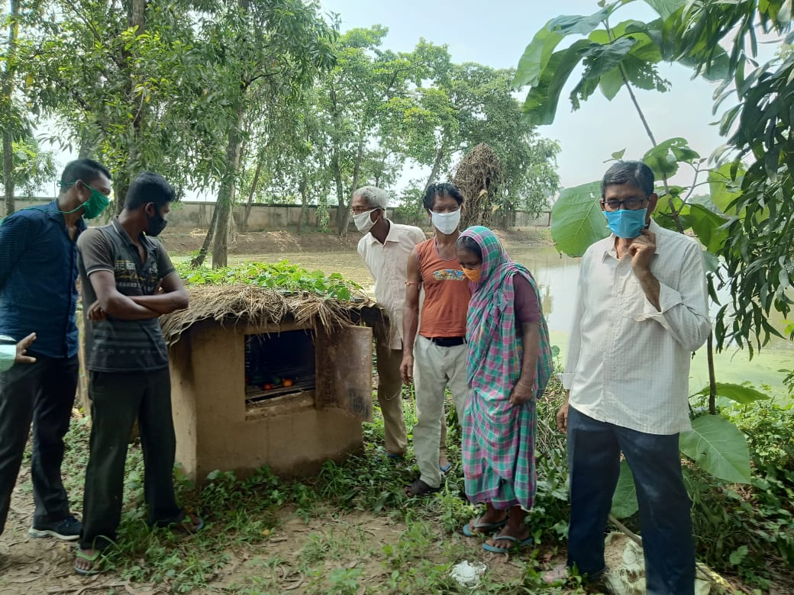

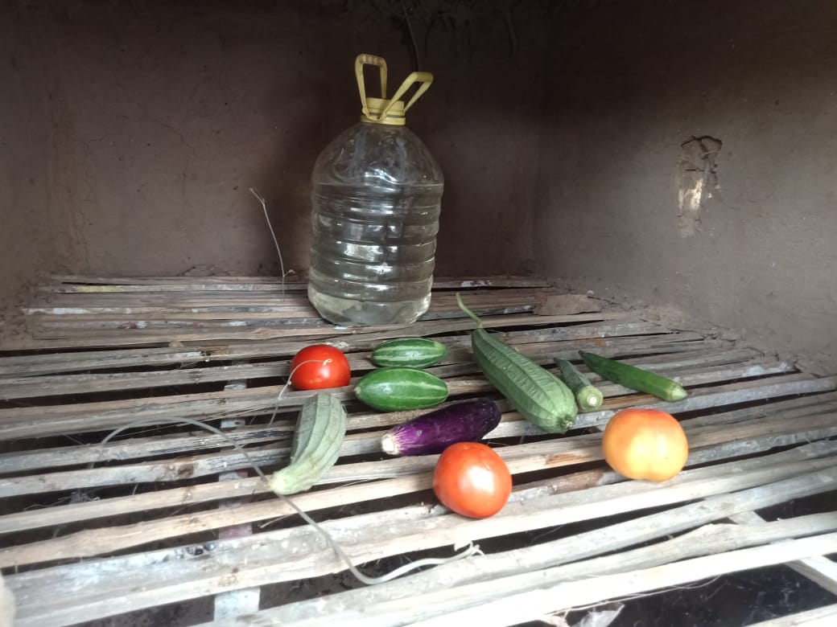

**Project - Vegerator: Natural Refrigerator for Veggies**

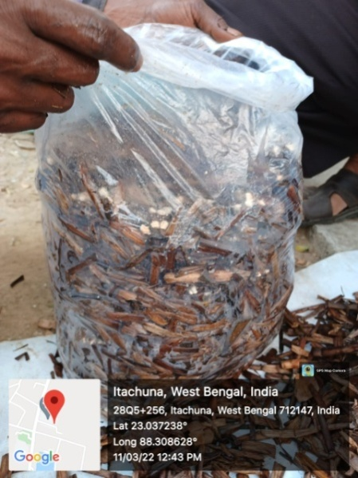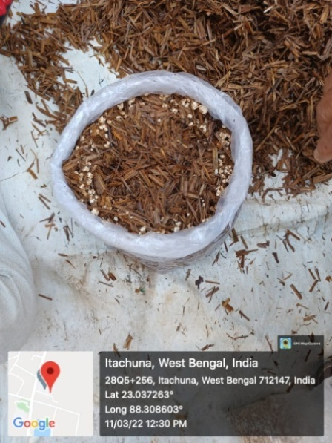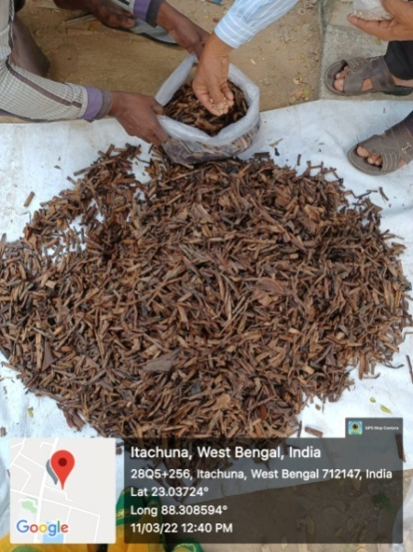

**Stages of economical mushroom cultivation – initiative by Canopy**

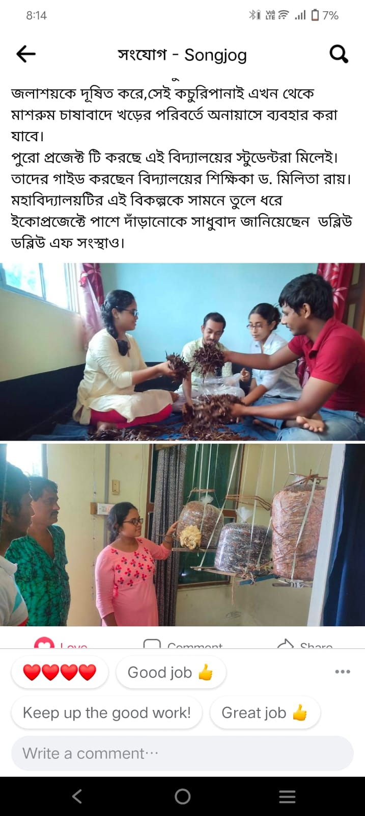

**The success**

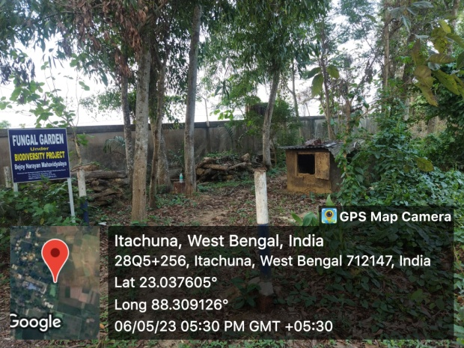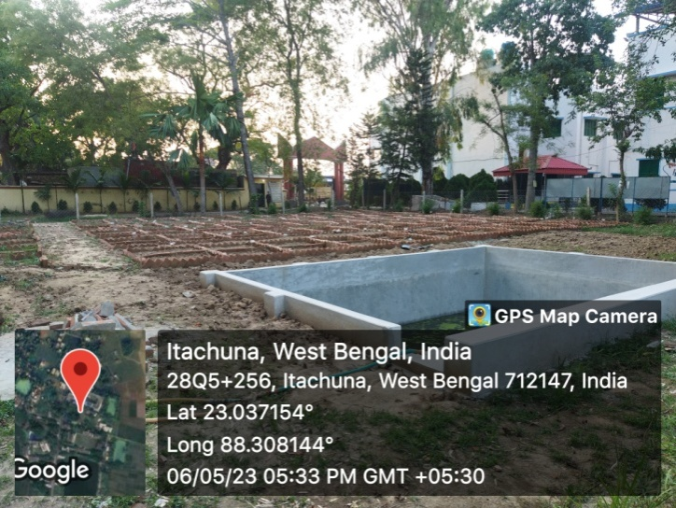

**Biodiversity Project to cultivate indegenous plants and creation of seed bank and Fungal garden**

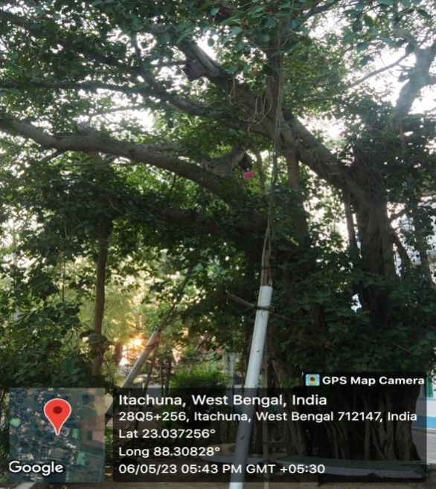

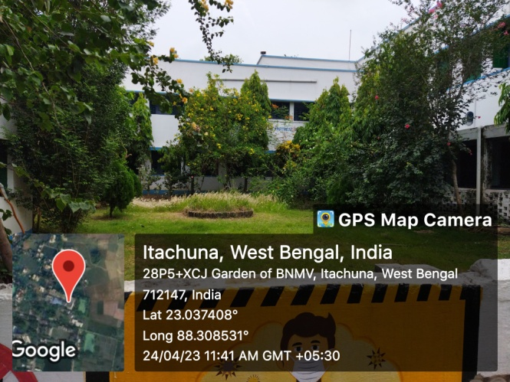

**Butterfly Garden** **Efforts to save BANYAN TREE and it’s prop roots**

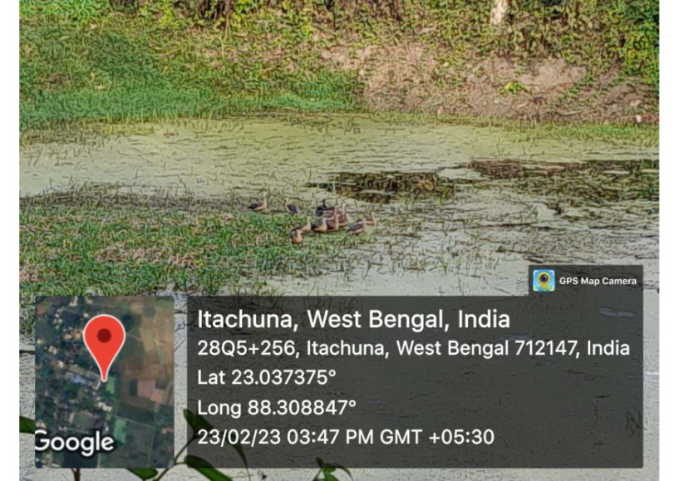

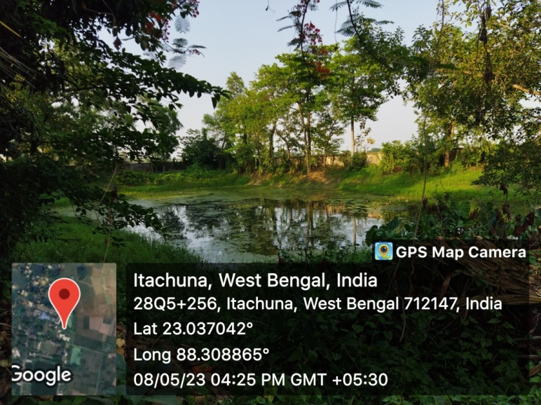

**Maintaining Water Body within Campus**

**Water Body with migratory birds (Lesser Whistling Teal) within Campus**

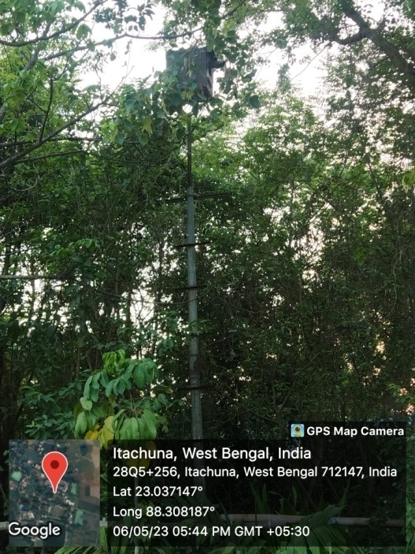

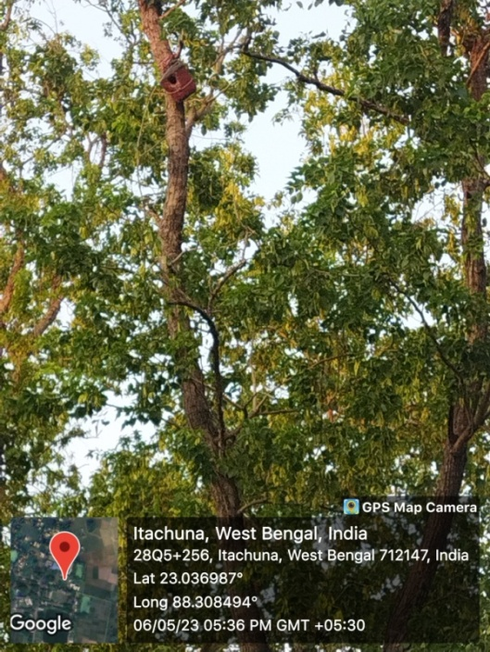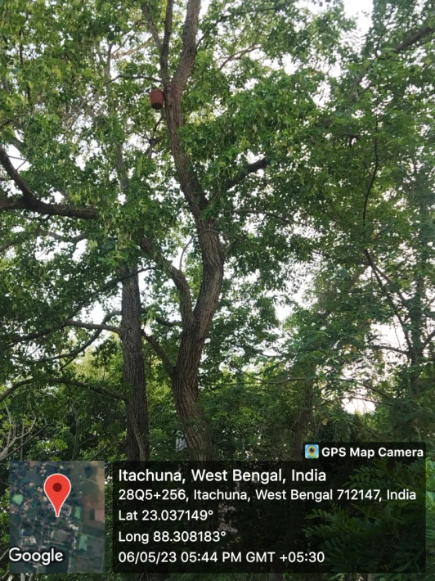

**Building bird nests within campus**

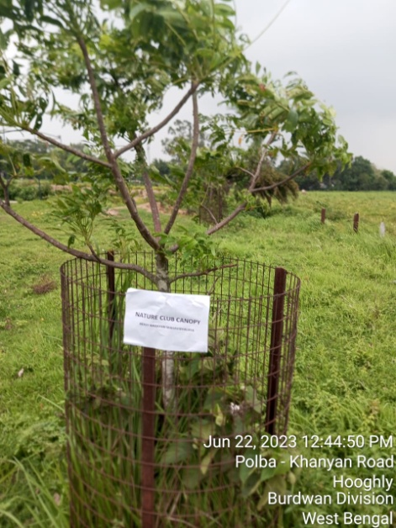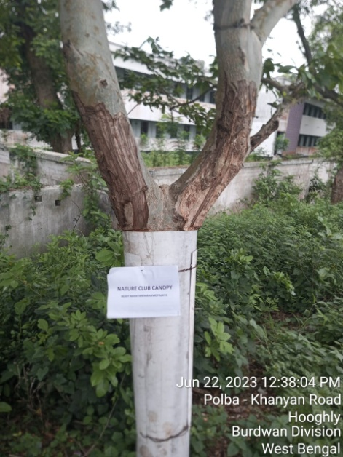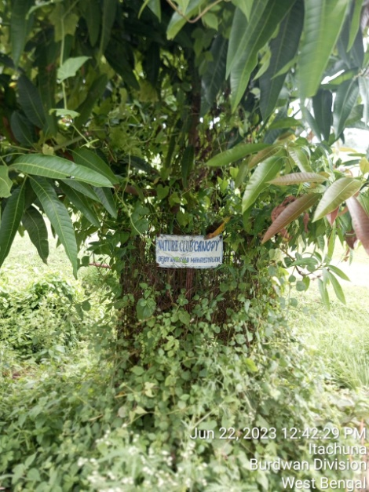

**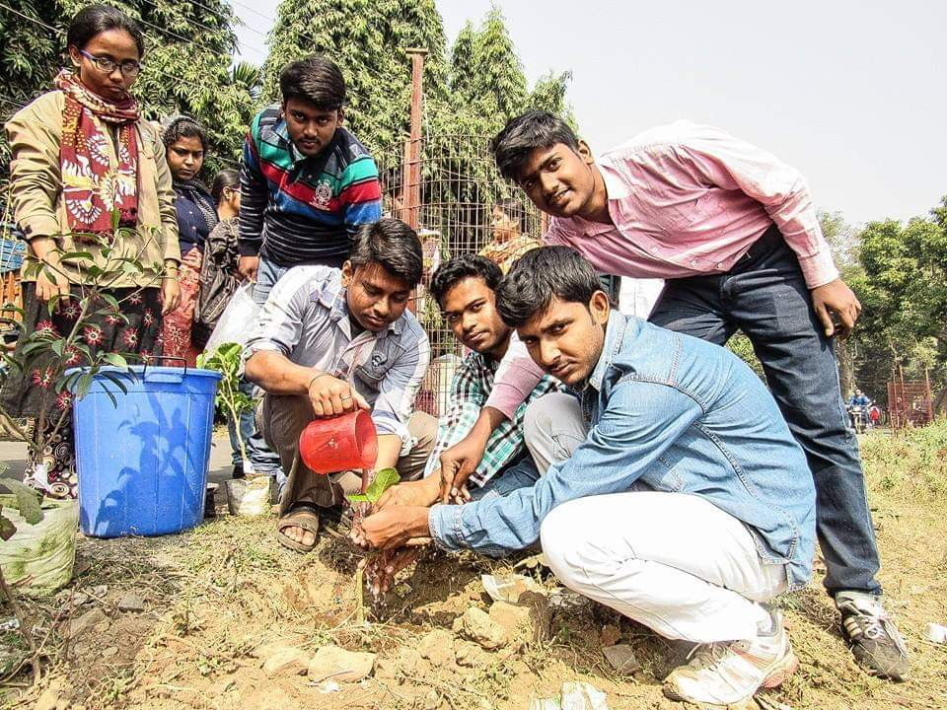**

**Plantation Activities outside the campus to promote greenary**

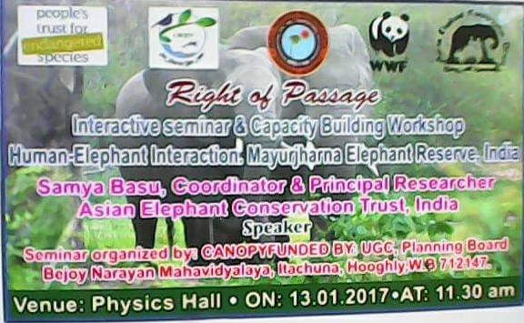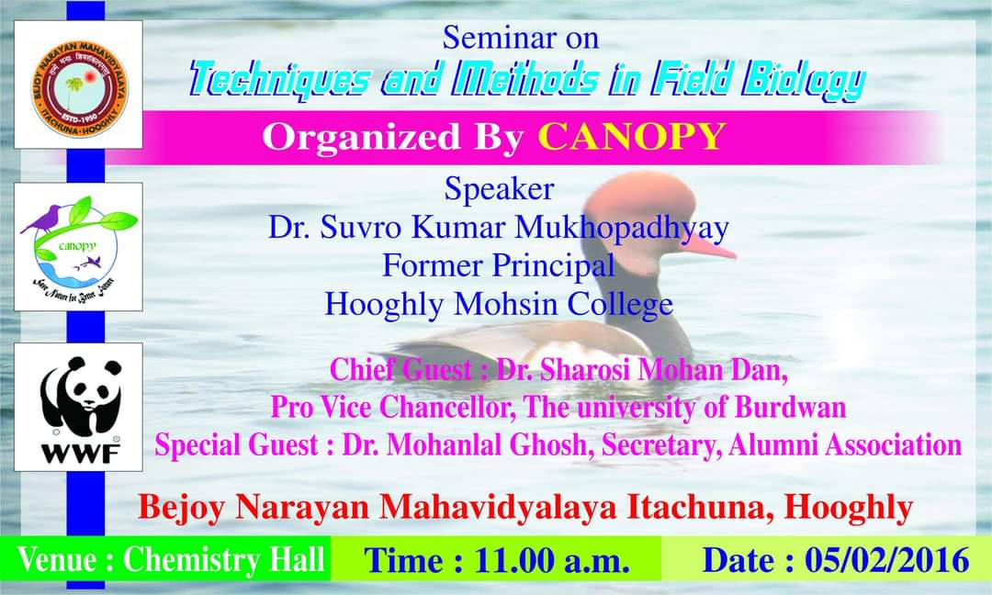

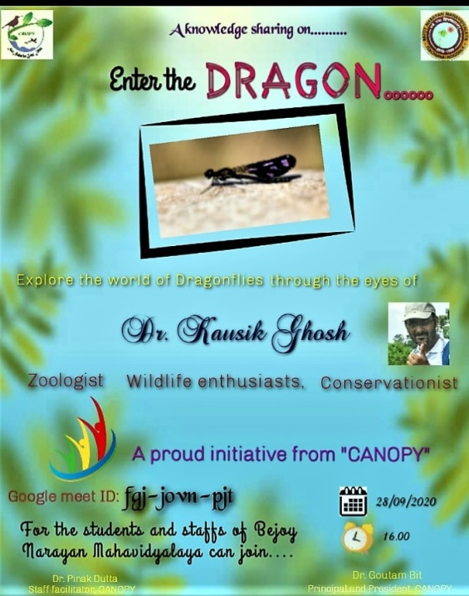

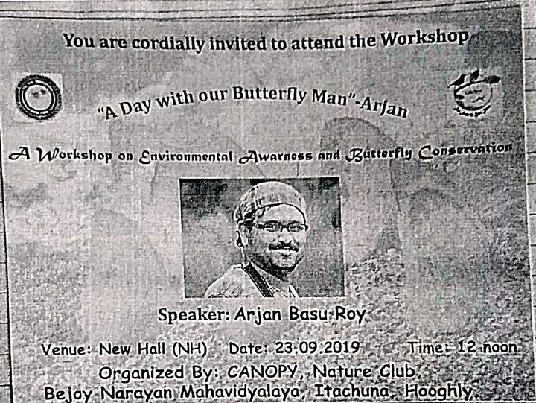

**Canopy organizes talks, workshops by eminent wildlife enthusiasts to bring about awareness about the need of taking care of “Mother Nature”**



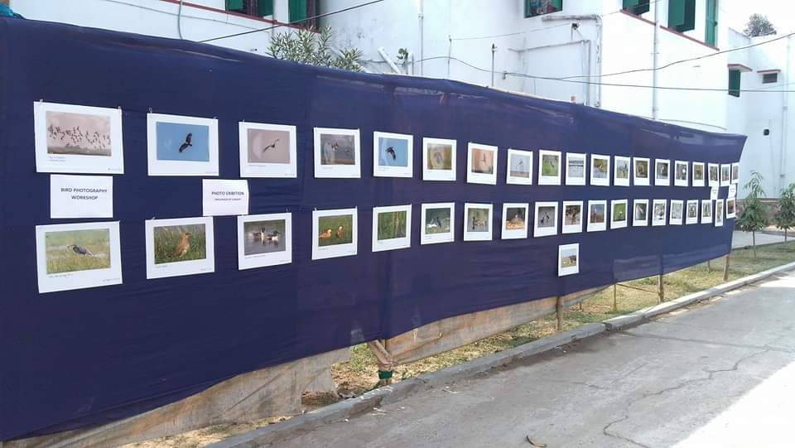

**Organizing Photo Competition, Photo Exhibition, Field trip (no exam credits) is a convinient way to spread awareness among youths on the benefits of going GREEN & SUSTAINABILITY**

**Second Nature Camp, CANOPY, Buxa Tiger Reserve, Alipurduar, West Bengal, 2017**

|  |  |
| --- | --- |
| H:\Canopy photo\Buxa Tiger Reserve 2017\DSC_1103.JPG | H:\Canopy photo\Buxa Tiger Reserve 2017\DSC_1108.JPG |
| A. The Team | B. On a field survey |
| H:\Canopy photo\Buxa Tiger Reserve 2017\DSC_1010.JPG | H:\Canopy photo\Buxa Tiger Reserve 2017\DSC_1312.JPG |
| C. Finding Wildlife is not easy! | D. The habitat |

**Third nature Camp, CANOPY, Sandakfu and Singalila National park, West Bengal, 2019**

|  |  |
| --- | --- |
| H:\Canopy photo\Sandakphu 2019\DSC_3450.JPG | H:\Canopy photo\Sandakphu 2019\DSC_3765.JPG |
| A. Starting the trek | B. At highest point of West Bengal |
| H:\Canopy photo\Sandakphu 2019\DSC_3863.JPG | H:\Canopy photo\Sandakphu 2019\DSC_6012.JPG |
| C. Coming down through snowy path | D. Rhododendron |

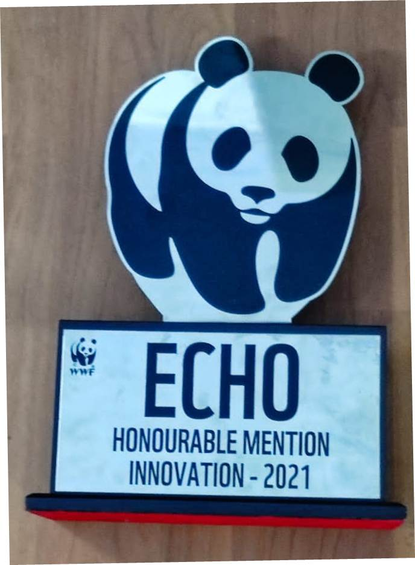

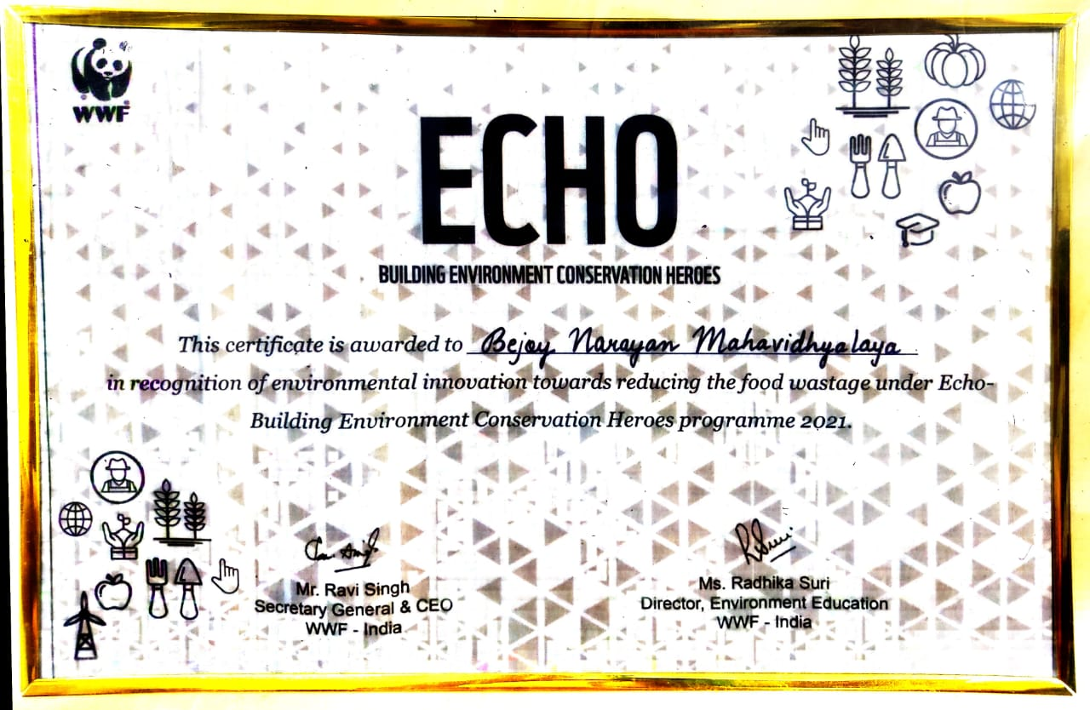

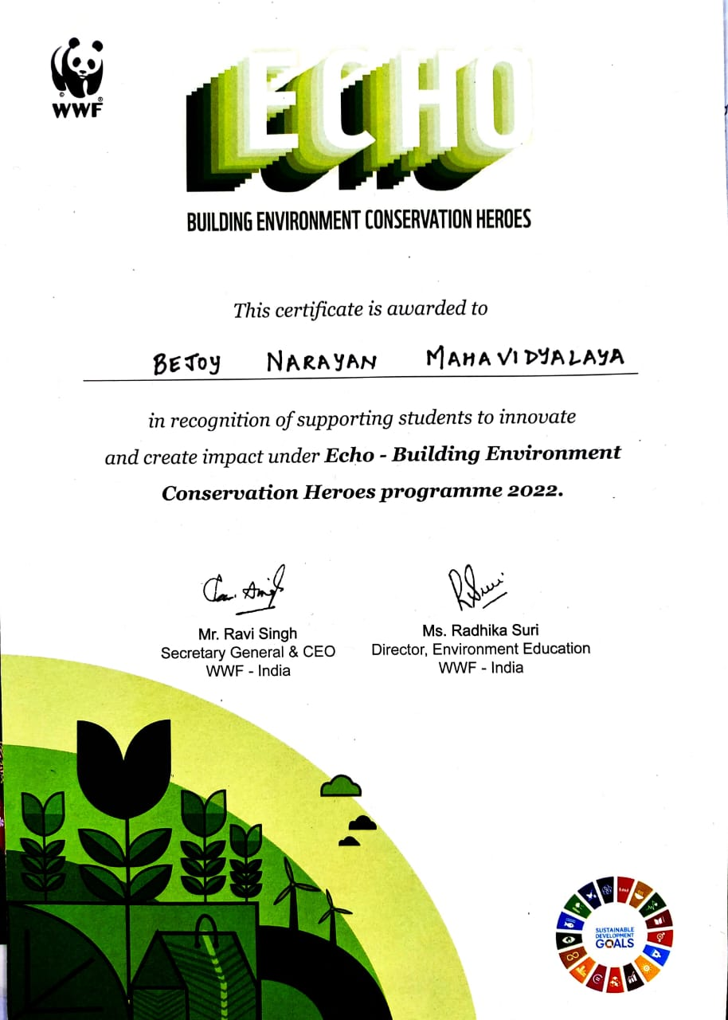

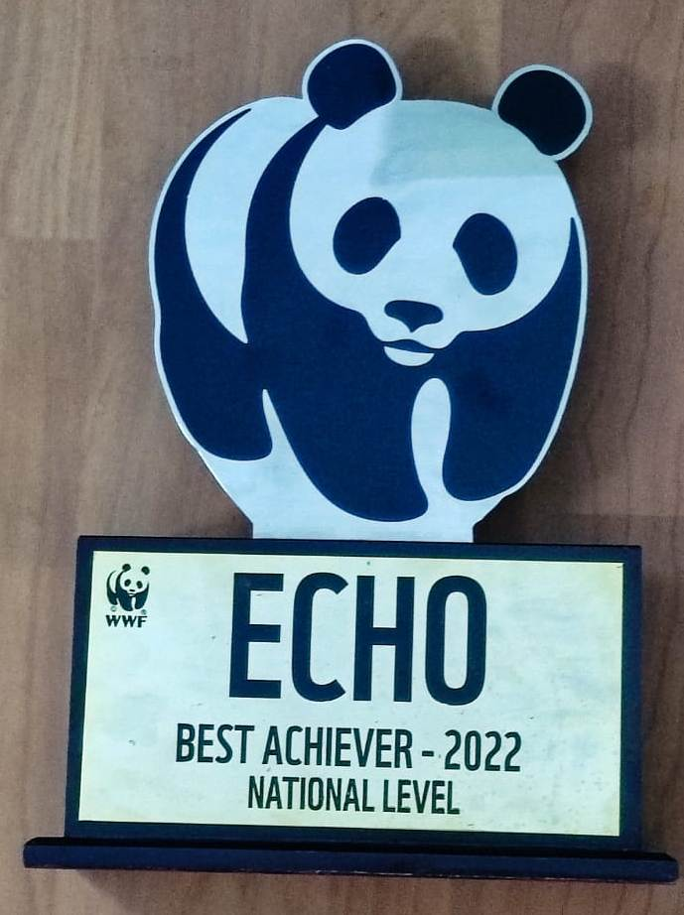

**THE RECOGNITION**